FIGURES March 14, 2022

Figure SX: Relationship between land cover classes and human activity (A.), the presence or mention of vulnerable individuals (B.), dog leash status (C.), coyote number (D.) and coyote health (E.). Colors represent Pearson’s residual values calculated post-hoc from chi square tests, with positive values (green – blue) indicating positive relationships and negative values (orange – red) indicating negative relationships. Significance is indicated by asterisks (\* P < 0.05, \*\* P <0.01, \*\*\* P < 0.001).

Figure SX: Relationship between coyote season and human activity (A.), the presence or mention of vulnerable individuals (B.), dog leash status (C.), coyote number (D.) and coyote health (E.). Colors represent Pearson’s residual values calculated post-hoc from chi square tests, with positive values (green – blue) indicating positive relationships and negative values (orange – red) indicating negative relationships. Significance is indicated by asterisks (\* P < 0.05, \*\* P <0.01, \*\*\* P < 0.001).

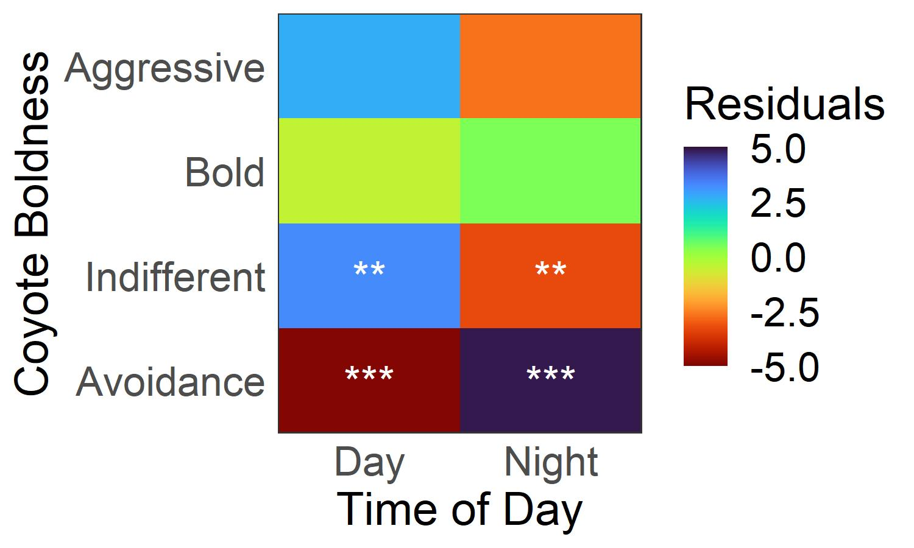

Figure SX. Relationship between coyote boldness and time of day, as shown by Pearson’s chi square residuals. Higher values (blue) indicate strong positive relationships while low negative values (red) indicate negative relationships. Significance is indicated by asterisks (\* P < 0.05, \*\* P <0.01, \*\*\* P < 0.001). Human concern is not shown as there was no significant relationship (X2 =